**CONSULATE GENERAL OF TURKEY IN ROTTERDAM**

**kids.mfa.gov.tr ABOUT ANNOUNCEMENT**

Discover Turkey with Can & Canan !! New web site for kids and teens,

Can & Canan talk about Turkish food, the Turkish language as well as sports and cultural and school life in Turkey.

Can & Canan is also available on iPad and iPhone “***Turkey for Youth***”

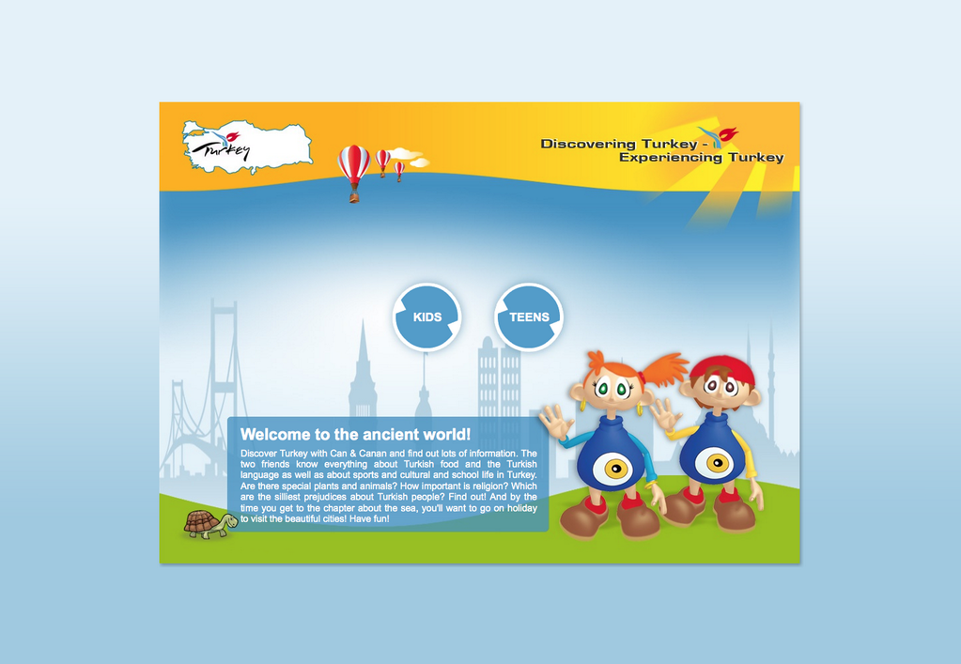

 kids.mfa.gov.tr